The Lotka-Volterra system defines the interaction between a predator and prey species within an environment. However, it does not account for various factors such as the crowding effect and is often implemented without realistic birth rates for both species. This research aims to simulate a predator and prey species while incorporating crowding effects and considering the impact of a higher intelligent species i.e., homo sapiens.

Initially the Lotka-Volterra system was modified to include the birth rate and crowding effects. The constants for these equations are based on realistic parameters:

* Birth rate of species – For this case rabbits and foxes were considered. With an average of 60 and 6 offspring per year respectively, the number was taken as a birth rate constant.
* Crowding factor for species – Here, the ability for a species to survive within a given area was considered and then the factors were normalized.
* Crowding effect for species – This considers the family/pack size of the species to simulate effects of increasing population within a given area.

Next, the previous system was tested with various hunting capabilities for the foxes to see how the populations stabilize if the foxes become more efficient at hunting rabbits. The results are documented below:

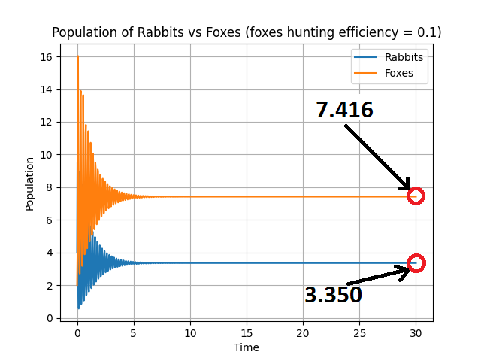

After this, the equations were further modified to incorporate the effects of introducing humans into such an environment. The predatory capability of foxes was kept at 0.25 to observe the divergence in populations with introduction of humans. There was an assumption that humans wouldn’t depend on hunting rabbits for survival and would have adequate tools to always save themselves from any fox or rabbit attacks. The population factor for humans was thus kept as 1. The results are documented below:

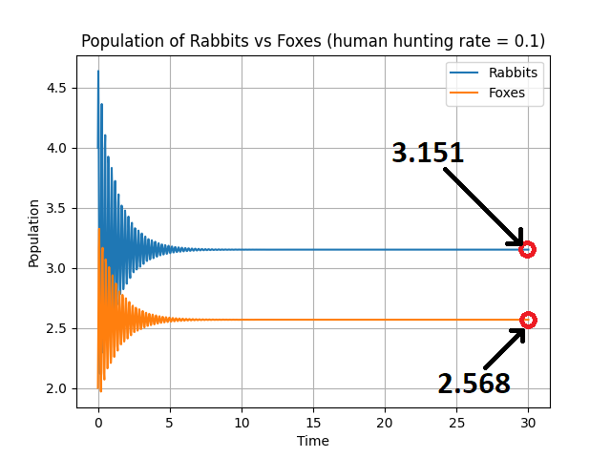

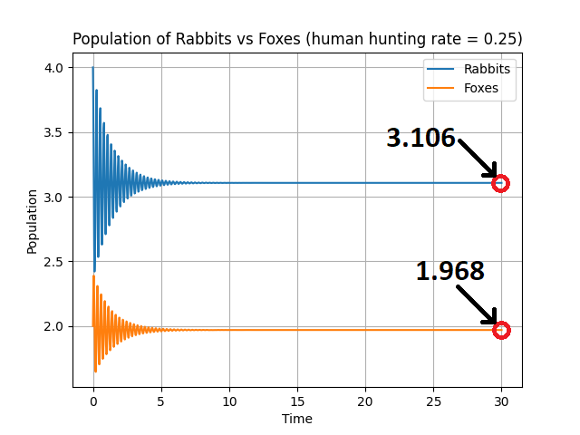

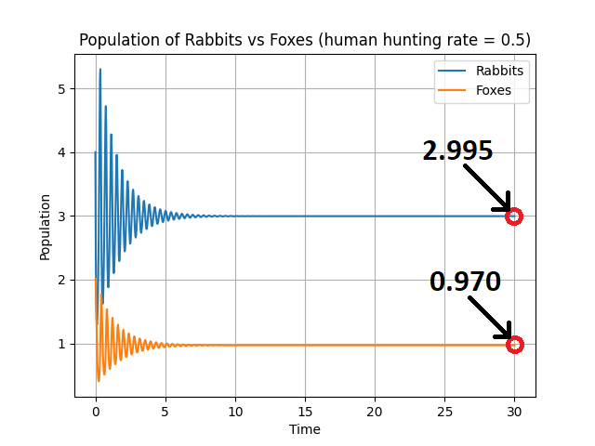

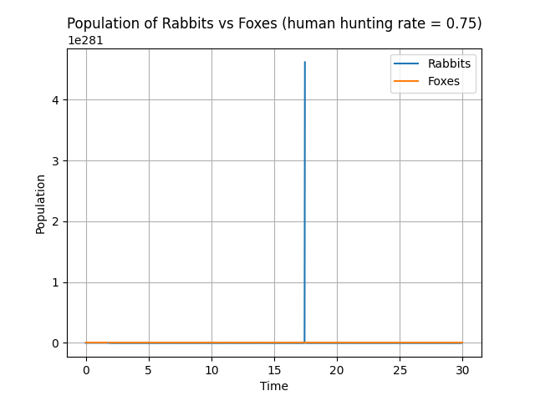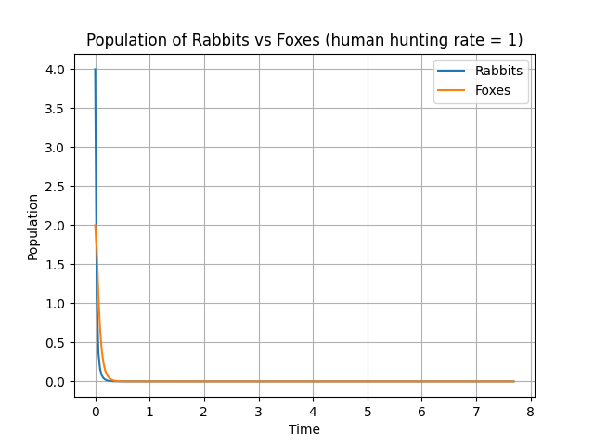

As observed in above graphs, the population of both species plummets to 0 as more humans become more predatory. On further comparison, it is further revealed that any interference by humans will decrease the population of both species.